ART WORK ANALYSIS OF “STARRY NIGHT” AND “LAST SUPPER”

Student’s Name
Course Code: Course Title
Date of Submission

Two Artworks Selected
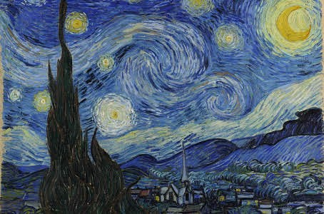
Fig 1: Starry Night by Vincent Van Gogh (1889)

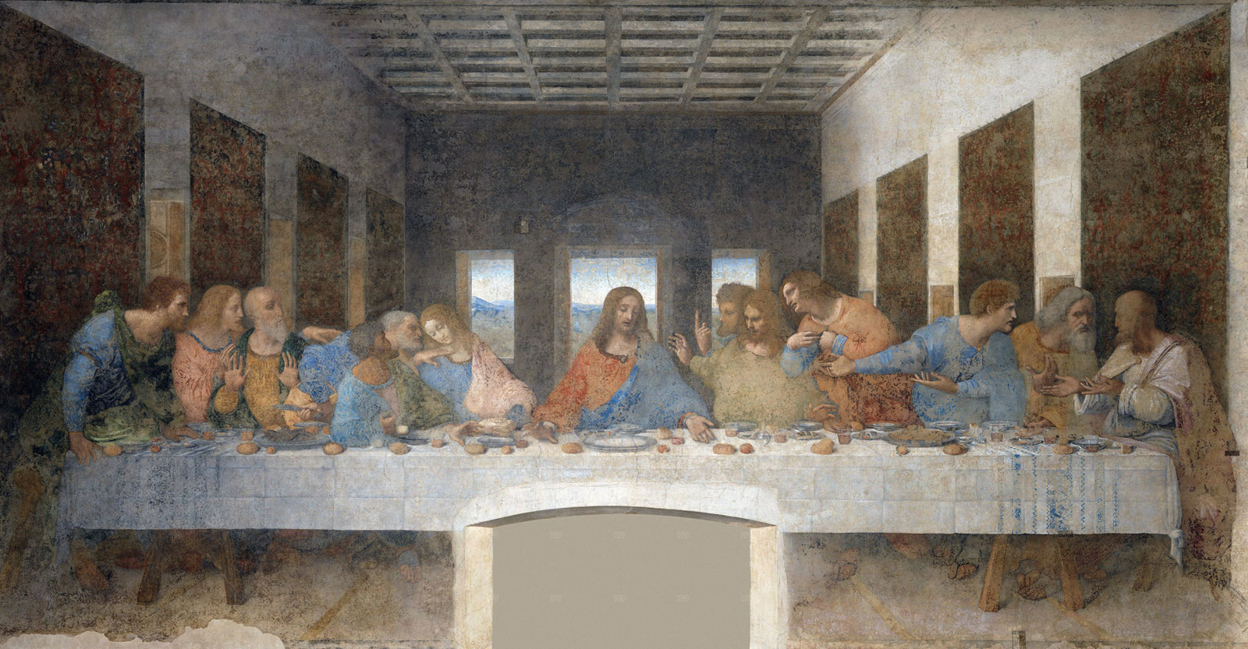
Fig 2: Last Supper, wall painting by Leonardo da Vinci, c. 1495–98
Analysis
The “Starry Night” was painted by a Dutch named Vincent Van Gogh (Paulson 2021). The image is found on Medievalists.net or the Khan Academy website. This artwork portrays a night vision outside his sanitarium room when he was sick in the hospital. Vincent painted his creative work in the year 1889. On the other hand, in “Last Supper” by Leonardo on his painting he portrays the message in the apostles’ faces such as fear, love, grief, and the hatred Judas portrays during the last supper with Christ. The picture is found in Medievalists.net or the khan Academy website.
Vincent used paintbrush strokes created by a process called the impasto technique. The stokes need to be at a certain pace. Using a large brush, he made every brushstroke longer, wider and thicker to achieve this paint. In contrast, Leonardo used oil paint which was painted on two layers of dry preparatory ground. The paint was not temporary since it was not attached to the wall (Harris and Zucker, 2021).
Vincent uses paints to express himself as a depressed man battling sicknesses, while Leonardo gives people an image of the last supper (Harris and Zucker 2021). Vincent bases on himself while Leonardo talks about the last supper. In “Starry Night,” Vincent uses colors and symbolism to portray his message, while Leonardo in “The Last Supper” uses human being body expression to convey his message. The similarity between the two artists is that they use the biblical point of view. Leonardo uses the Last supper images in Matthew 26. In comparison, Vincent uses the book of genesis, the story of Joseph and the stars. Vincent draws eleven stars to symbolize his dreams. Both paintings have a religious point of view. “Starry Night” is a Painting showing a depressed man depicted by the black paintings. The painter is depressed due to his suffering from various illnesses. He even paints while in hospital.
In conclusion, the artwork by Van Gogh has a deep meaning. It is painted by a depressed man who has health challenges and uses the paint to give himself hope. In contrast, the artwork by Leonardo is a paint to show the feelings of the twelve disciples of Christ during the Last supper.

Bibliography
Harris, Beth, and Steven Zucker. “The Last Supper by Leonardo Da Vinci (Article).” Khan Academy. Khan Academy. Accessed May 2, 2021. https://www.khanacademy.org/humanities/ap-art-history/early-europe-and-colonial-americas/renaissance-art-europe-ap/a/leonardo-last-supper
Paulson, Noelle C. “Van Gogh, The Starry Night (Article).” Khan Academy. Khan Academy. Accessed May 2, 2021. https://www.khanacademy.org/humanities/ap-art-history/later-europe-and-americas/modernity-ap/a/van-gogh-the-starry-night

